
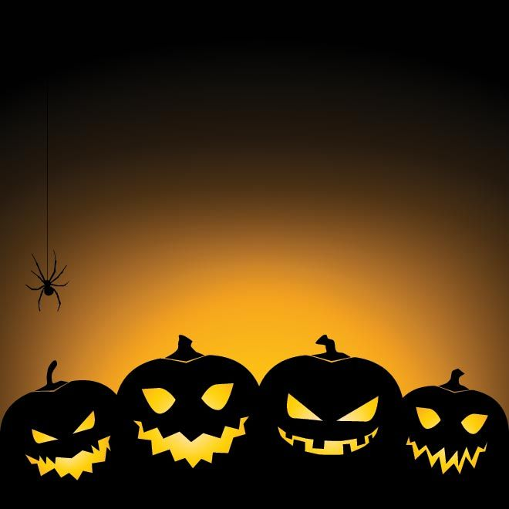
“HALLOWEEN FEST”

MAYOBRIDGE SOCIAL CLUB
FRIDAY 28TH OCTOBER 2016
FANCY DRESS PARTY (over 18)
Doors open @ 9pm
Entry £5
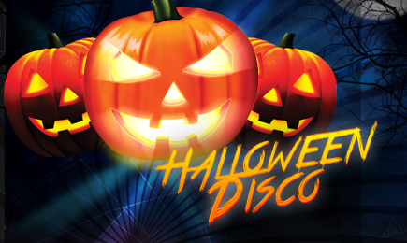

SUNDAY 30TH OCTOBER
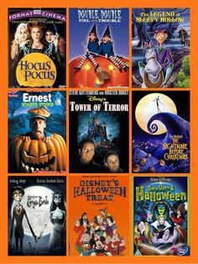
KIDS MOVIE @ 3PM (PRIMARY 1-7) £3

SUNDAY 30TH OCTOBER
TEEN FANCY-DRESS DISCO
AT 9PM £3


ALL IN AID OF SOUTHERN AREA HOSPICE SERVICES

